**ACKNOWLEDGEMENT SLIP**

(To be filled in by the investor)

**Application No.**

SIP through Auto Debit (NACH / PDC)

Folio No./ Application No.

Received from: Mr./ Ms. /M/s

Dated

/

/

□

 

SIP Mandate Form

□

 

NACH/PDC/Auto Debit Form

**SIP REGISTRATION CUM MANDATE FORM (NACH / DIRECT DEBIT/PDC)**

**New Investors subscribing to the scheme through SIP must complete this form compulsorily alongwith Common Application Form**

*Application should be submitted atleast 30 days before the 1st debit*

|  |  |  |  |  |  |  |  |  |
| --- | --- | --- | --- | --- | --- | --- | --- | --- |
| **Please** () |  |  **SIP Registration** |  |  **SIP Renewal** |  |  **SIP Mandate Modification** |  |  **SIP Cancelation** |
|  |  |  |  |

For Office use only: RM Code

|  |  |  |  |
| --- | --- | --- | --- |
| **ARN Code and Name of Distributor** | **Sub-Broker Code** | **Sub-Broker ARN Code** | **EUIN\*** (Employee Unique Identification Number) |
| **71722** |  |  |  |

**Declaration for “execution-only” transaction (only where EUIN box is left blank)**

* I/We hereby confirm that the EUIN box has been intentionally left blank by me/us as this is an “execution-only” transaction without any interaction or advice by the employee/relationship manager/sales person of the above distributor or notwithstanding the advice of in-appropriateness, if any, provided by the employee/relationship manager/sales person of the distributor and the distributor has not charged any advisory fees on this transaction.

|  |  |  |  |
| --- | --- | --- | --- |
| **SIGNATURE(S)** |  |  |  |
| **1st Applicant / Guardian / Authorised Signatory** | **2nd Applicant / Authorised Signatory** | **3rd Applicant / Authorised Signatory** |

Upfront commission shall be paid directly by the investor to the AMFI registered Distributors based on the investors’ assessment of various factors including the service rendered by the distributor

**TRANSACTION CHARGES FOR APPLICATIONS THROUGH DISTRIBUTORS/AGENTS ONLY**

In case the subscription amount is Rs. 10,000/- or more and if your Distributor has opted to receive Transaction Charges, Rs. 150/- (for first time mutual fund investor) or Rs. 100/-(for investor other than first time mutual fund investor) will be deducted from the subscription amount and paid to the distributor. Units will be issued against the balance amount invested.

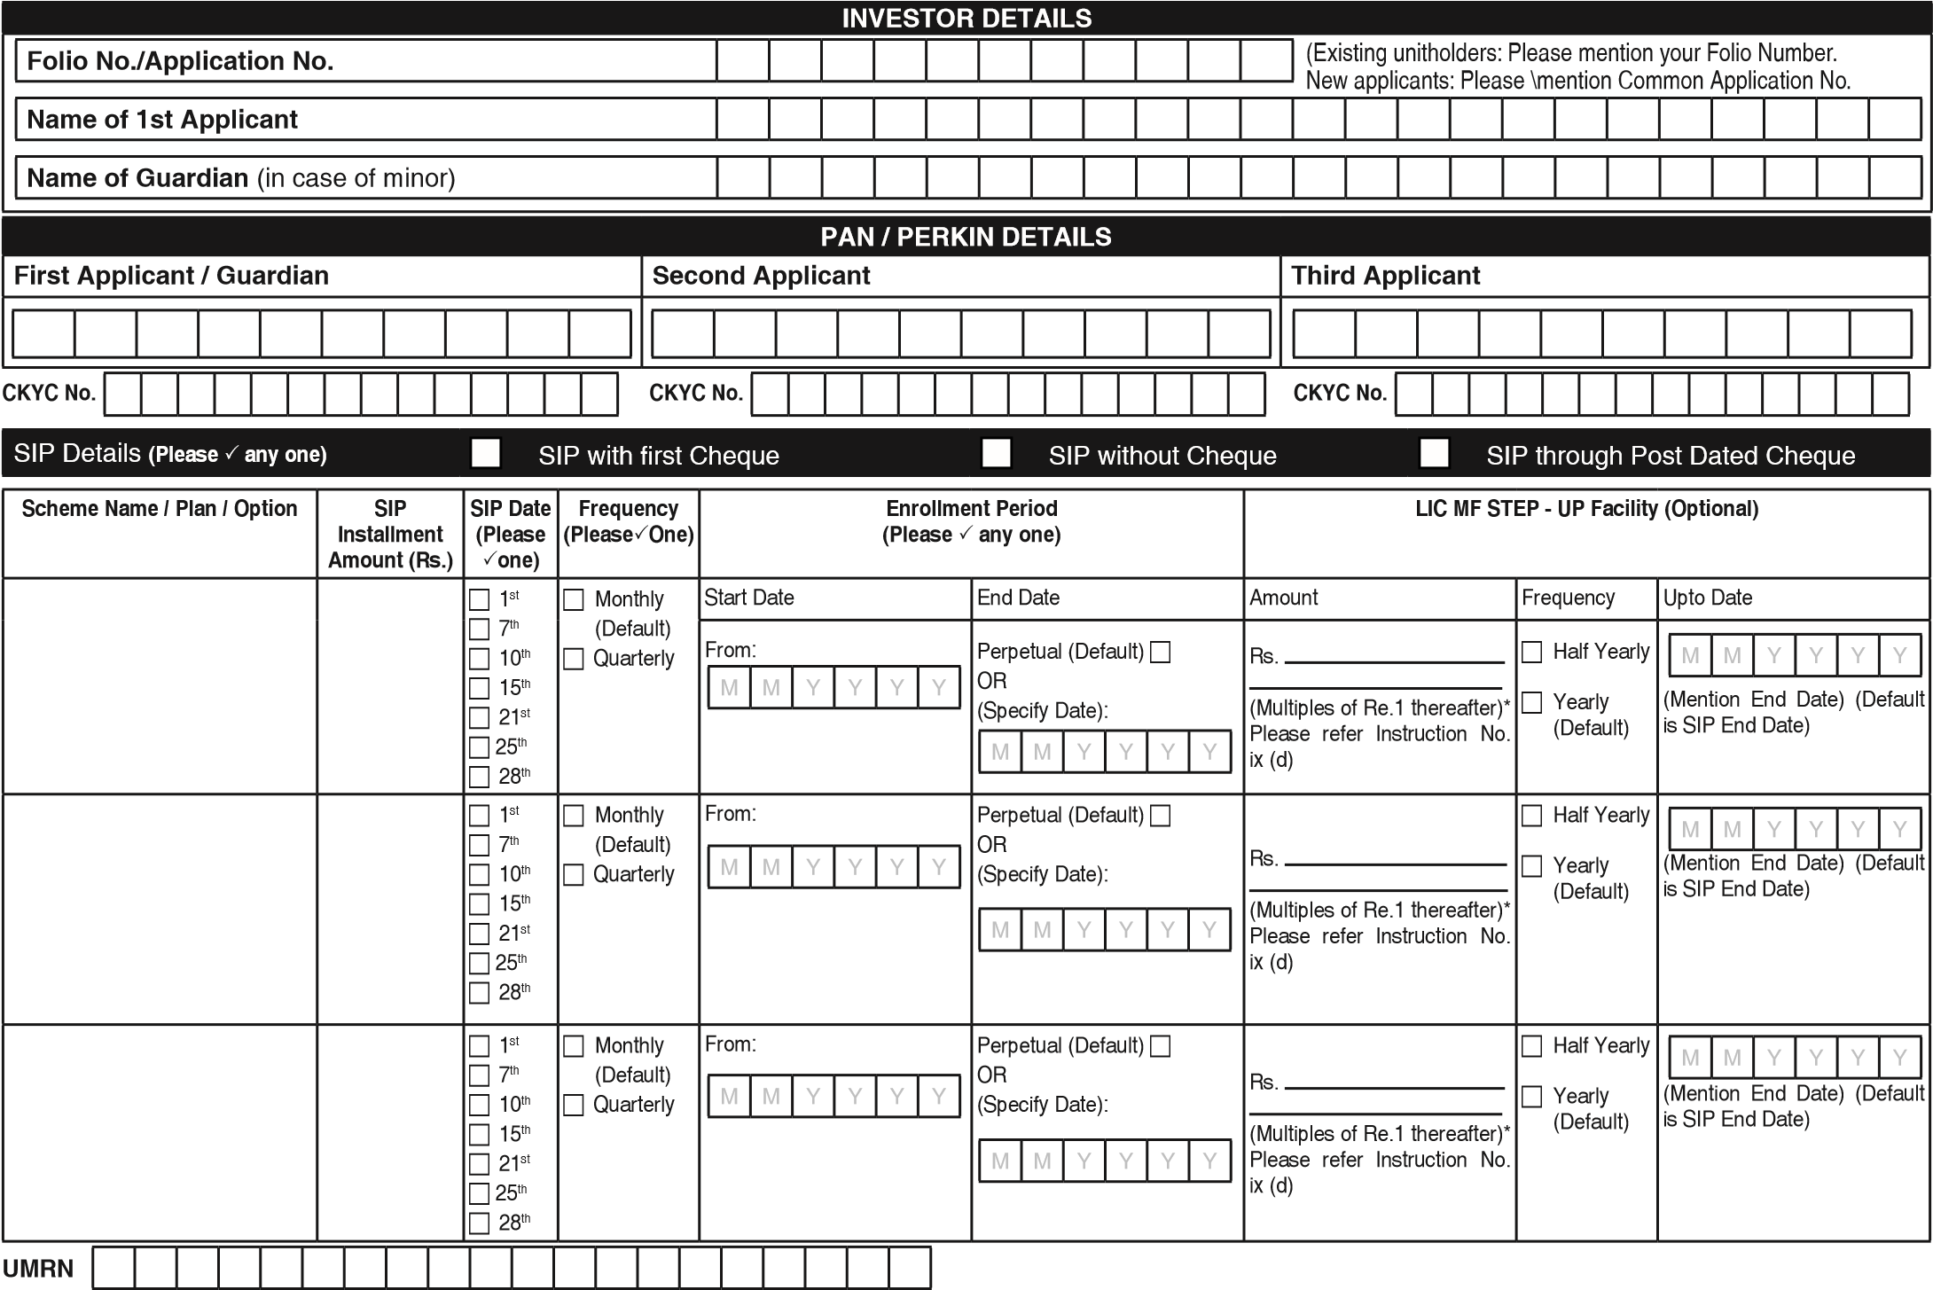

If you are an existing SIP investor and wish enroll another SIP with the same bank. Please mention the UMRN No. (Please check the maximum amount given earlier)

|  |  |
| --- | --- |
| **SIP THROUGH POST DATED CHEQUES** | |
| No. of cheques enclosed including first cheque | Drawn on Bank and Branch |
| Account type | Cheque No. should be in continuous series From       To       |
| **DECLARATION** :I/We hereby declare that the particulars given in this mandate form are correct and express my willingness to make payments towards investment in the schemes of LIC Mutual Fund. I/We are aware that LIC Mutual Fund and its service providers and bank are authorized to process transactions by debiting my/our bank account through Direct Debit / NACH facility. If the transaction is delayed or not effected for reasons of incomplete or incorrect information, I/We would not hold the user institution responsible. I/We will also inform LIC Mutual Fund/RTA about any changes in my/our bank account. I/We confirm that the aggregate of the lump sum investment (fresh purchase & additional purchase) and SIP installments in rolling 12 months period or financial year i.e. April to March does not exceed Rs. 50,000/- (Rupees Fifty Thousand) (applicable for “Micro investments” only). The ARN holder has disclosed to me/us all the commissions (in the form of trail commission or any other mode), payable to him for the different competing Schemes of various Mutual Funds from amongst which the Scheme is being recommended to me/us. I/We have read, understood and agreed to the terms and conditions and contents of the SID, SAI, KIM and Addenda issued from time to time of the respective Scheme(s) of LIC Mutual Fund. I/We hereby authorize the bank to honour such payments for which I/We have signed and endorsed the Mandate Form. | |

**First Applicant / Guardian Second Applicant Third Applicant**

# TERMS & CONDITIONS

**(I)** SIP Enrolment Form should be completed in English and in Block Letters only. Please tick in the appropriate box (), where boxes have been provided. Enrolment Form complete in all respect should be submitted at any of the Official Points of Acceptance of LIC Mutual Fund.

* Please read the Scheme Information Document (SID), Statement of Additional Information (SAI) and Key Information Memorandum (KIM) and relevant addendum, if any, of the respective schemes carefully before investing. All applicants are deemed to have read, understood and accepted the terms subject to which this offer is being made and bind themselves to the terms upon signing the application form and tendering payment.
* PAN is a mandatory requirement for all investors for investing in the mutual fund, except for Micro Investments and investors from Sikkim. Micro Investments exemption will be applicable only to investments by individuals [including NRIs but excluding Persons of Indian Origin (PIOs)], minors, sole proprietary firms and to investments made by joint holders. KYC Compliance is mandatory for all investors, irrespective of the amount of investment.
* A Micro SIP application will be rejected where it is found that the registration of the application will result in the aggregate of Micro SIP installments in a financial year exceeding 50,000 or where there are deficiencies in supporting documents. **(II) SIP Registration**:
* Existing unit holders need not fill in the common investment application form. New applicants need to compulsorily fill in all sections in the common Application Form in addition to this SIP form form except LIC MF Unit Linked Insurance Scheme.
* Please furnish the existing folio number or application number in case of new investor in SIP mandate form.  Investors are required to submit SIP request at least 30 days prior to the date of first debit through NACH/Direct debit.  Minimum SIP registration period should be for one year. SIP start date shall not be beyond 60 days for monthly SIP and for Quarterly SIP 90 from the date of submission of SIP application.
* SIP facility is available only on specific dates of the month viz. 1st/7th/10th/15th/21st/25th/28th. In case of LIC MF Unit Linked Insurance Scheme SIP date is 15th of every month only.  Please indicate whether the request is for registration of a new SIP/Micro SIP, renewal of an existing SIP or for change in bank mandate of an existing SIP or cancelation of SIP.
* Each of the installments under each SIP (excluding the initial cheque) should be of the same date and amount. LIC MF Unit Linked Insurance Scheme all installment should be of equal amount.
* Existing investors can start SIP without cheque however the copy of the canceled cheque is mandatory.
* In case the unitholder has not indicated SIP preferences completely in the form or in case of any discrepancy, the default SIP frequency would be ‘Monthly’ and the default SIP date would be ‘10th’. In case the SIP ‘End Period’ is incorrect or not mentioned by the investor in the SIP form, then the default ‘End Period’ will be December 2099. However, SIPs will be registered in a folio held by a minor only till the date of the minor attaining majority, even though the instructions may be for a period beyond that date. The facility will automatically stand terminated upon the Unitholder attaining 18 years of age.
* The enrolment period i.e Start and End Month/ Year specified for the SIP should be less than or equal to the enrolment period mentioned in the Mandate If the initial cheque given from different bank from the bank details mentioned in SIP mandate then it is mandatory to submit the copy of cancelled cheque leaf (issued by the bank branch mentioned overleaf) in SIP Mandate.

## (III ) New Fund Offer -

* Investors may submit the mandate Form during the NFO period for such Schemes as may be decided by AMC from time to time. In such case the mandate shall commence on the dates stipulated by the Investor after a gap of at least 20 days from the date of re-opening of the Scheme for purchase and redemption of units. For e.g. If the Units of the Scheme re-opens for purchase and redemption post NFO on 16th December, the earliest Installment date can be only on 7th January of the following year.
* In case SIP/ Micro SIP investments are made through ‘Third Party Payments’ i.e. payment made through an instrument issued from a bank account other than that of the first named applicant/ investor mentioned in the application form, Investors are required to additionally fill up & submit the ‘Third Party Payment Declaration Form’(available at any of our ISCs or on our website :www.licmf.com along with the SIP Enrolment Form.
* In respect of enrollments, the Load Structure prevalent at the time of enrollment shall govern the investors during the tenure. (Please refere SID of respective scheme)

## (IV) SIP through Post dated Cheques- (Only CTS-2010 compliant cheques)

All installment cheques excluding initial investment cheque under MSIP & QSIP should be of uniform amount and date. SIP facility is available only on specific dates of the month viz. 1st/7th/10th/15th/21st/25th/28th In case of LICMF ULIS SIP only 15th of every month as a date of SIP is available. Please draw your cheques in the name of the Scheme/ Plan in which the amount is invested. Returned Cheques, if any, may not be presented again.

1. **SIP Transactions related** The SIP enrollment will be discontinued in cases where three consecutive installments are not honored or the Bank Account [for NACH (Debit clearing)/ Direct Debit etc.] **ULIS**- The SIP enrollment will be discontinued if no credit comes for a single month.

● In case the first SIP installment is processed (as the cheque may be banked) and the application is found to be defective, the SIP registration will be ceased for future installments. Investor will be sent a communication to this effect. No refunds shall be made for the units already allotted. However, redemptions/ switch-outs shall be allowed. (Please read SID/KIM of respective scheme).

Units will be allotted on the applicable dates subject to realization of funds where total SIP investments on a date amount to Rs. 2 lakh or more. In case the date falls on a Non- Business Day or falls during a book closure period, the immediate next Business Day will be considered for the purpose of determining the applicability of NAV subject to the realization of proceeds. Further, in case of first SIP investment accepted through cheque drawn on a location where ISCs of LIC Mutual Fund does not have a presence but HDFC Bank has a presence, units will be allotted on the date on which subscription proceeds are realized.

The Unit holder(s) agree that the Fund/AMC / RTA and their agents shall not be held liable for any unsuccessful registration and or transaction due to any action or inaction of the unitholders’ bank including but not limited to reasons mentioned below and agree to indemnify the Fund/AMC/RTA for all liabilities, losses, damages and expenses which they may consequent sustain or incur either directly or indirectly:

* 1. Loss of the debit mandate form in transit from point of acceptance of the form to RTA head office and further to the unit holder(s)’ bank branch;
  2. Non acceptance or rejection of debit mandate for whatsoever reason by the unit holder(s)’ bank branch, with or without any reason assigned by the unit holder(s) bank; c. Non registration of the debit mandate by the unit holder(s)’ bank and branch.

d. Deemed registration due to non confirmation of registration or rejection by the bank and any subsequent rejection of debit of bank account for funds; e. Non availability of funds in the bank account of the Unit holder(s) at the time of debit.

* 1. Rejection of registration or transaction debit for any reason or without assigning any reason whatsoever.
  2. AMC / RTA will not be responsible for the charges levied by his banker for registering / processing any transaction.

1. **Discontinuation of SIP**- Investors can discontinue his SIP at any time by sending a cancelation of mandate to any Official Point of Acceptance or to the registrar Karvy.

Notice of such discontinuance should be received at least 20 days prior to the due date of the next installment / debit.

1. **Change of Bank mandate** - Investor can change his bank mandate by sending the mandate with option selected as “Create Mandate” Request for change in bank account submitted at least 30 days before the next SIP Auto Debit.

## (VIII) STEP-UP Facility

a. STEP-UP facility offers frequency at half yearly and yearly intervals. In case the STEP-UP frequency is not specified, it will be considered as yearly frequency. b. Under this facility the Investor can increase the SIP installment at pre-defined intervals by a fixed amount. c. This facility is available for individual investors only.

1. Minimum STEP-UP amount would be Rs.500/- and in multiples of Re. 1/- thereafter for all the schemes of the Fund that offer SIP facility except LIC MF Tax Plan where in minimum STEP-UP amount would be Rs. 500/- and in multiples of Rs. 500 thereafter.
2. In case the investor does not specify STEP-UP amount, Rs. 500/- will be considered as the STEP-UP amount and the request will be processed accordingly. f. STEP-UP facility would be available to all new SIP enrolments.
3. Existing investors registered for SIP through NACH/ECS/Direct Debit facility and intending to avail STEP-UP facility will be required to cancel the existing SIP and enroll a fresh SIP with STEP-UP details.
4. It would be mandatory for investor to mention in ‘SIP cum Registration Mandate’ the period (month - year) upto which he wishes to avail STEP-UP facility.

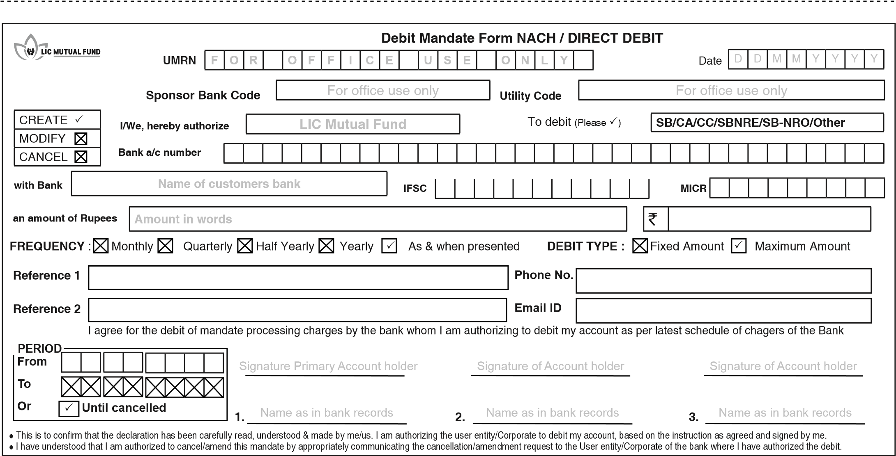

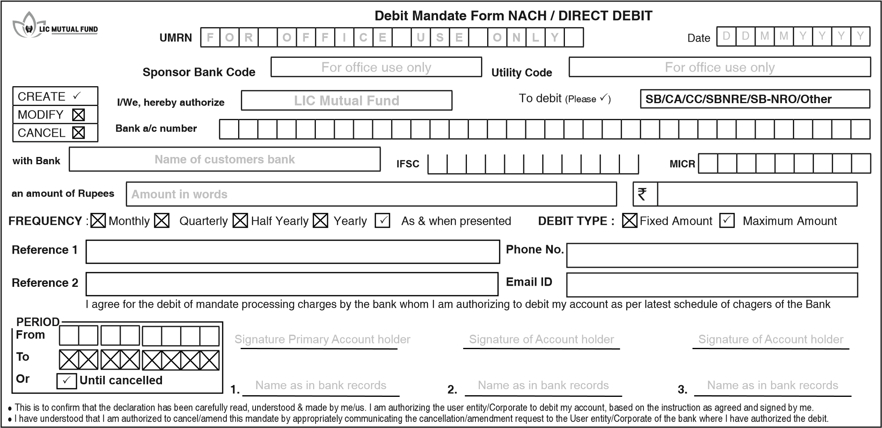

**General Instruction for filling up NACH Mandate.**

Mandatory fields for filling NACH mandate. In case any of these fields are not filled, mandate will be rejected. · Account Type  Bank A/c. number  Bank Name

* IFSC code or MICR code (As per the Cheque / Pass book)  Amount in Words (Maximum amount)  Amount in Figures (Maximum amount)  Period Start Date and End Date or until cancelled  Account Holder Signature  Account Holder Name as per Bank Record.  Do not write any extra details on the mandate. · Investor can change his bank mandate by sending the new mandate with option selected and 'modify mandate'.  Please attach a copy of canceled cheque along with mandate.  AMC do not charge investor for enrolling SIP however Bank may levy charges to investor's bank account for NACH registration

**General Instruction for filling up NACH Mandate.**

Mandatory fields for filling NACH mandate. In case any of these fields are not filled, mandate will be rejected. · Account Type  Bank A/c. number  Bank Name

* IFSC code or MICR code (As per the Cheque / Pass book)  Amount in Words (Maximum amount)  Amount in Figures (Maximum amount)  Period Start Date and End Date or until cancelled  Account Holder Signature  Account Holder Name as per Bank Record.  Do not write any extra details on the mandate. · Investor can change his bank mandate by sending the new mandate with option selected and 'modify mandate'.  Please attach a copy of canceled cheque along with mandate.
* AMC do not charge investor for enrolling SIP however Bank may levy charges to investor's bank account for NACH registration